# IMG_256Michael Jackson Biography

(1958–2009)

Michael Jackson was a multi-talented musical entertainer who enjoyed a chart-topping career both with the Jackson 5 and as a solo artist. He released one of the best-selling albums in history, 'Thriller,' in 1982, and had other number-one hits on 'Bad' and 'Off the Wall.'

## **Who Was Michael Jackson?**

Known as the "King of Pop," Michael Jackson was a best-selling American singer, songwriter and dancer. As a child, Jackson became the lead singer of his family's popular group, the [Jackson 5](https://www.biography.com/news/michael-jackson-growing-up-gary-indiana-jackson-5). He went on to a solo career of astonishing worldwide success, delivering No. 1 hits from the albums Off the Wall, Thriller and Bad. In his later years, Jackson was dogged by allegations of child molestation. He died in 2009 at age 50 of a drug overdose just before launching a comeback tour.

## **Early Life and Family**

Michael Joseph Jackson was born on August 29, 1958, in Gary, Indiana. Under his father's encouragement, Jackson's career in music began at the age of 5.

Jackson's mother, [Katherine Jackson](https://www.biography.com/people/katherine-jackson-466952), was a homemaker and a devout Jehovah's Witness. His father, [Joseph Jackson](https://www.biography.com/people/joseph-jackson-467150), had been a guitarist who put aside his musical aspirations to provide for his family as a crane operator. Behind the scenes, Joseph pushed his sons to succeed. He was also reportedly known to become violent with them.

Jackson was one of 10 children; nine Jackson siblings all made marks in the music industry.

## 1610609147(1)**The Jackson 5**

Joseph believed his sons had talent and molded them into a musical group in the early 1960s that would later become known as the Jackson 5.

At first, the Jackson Family performers consisted of Jackson's older brothers, Tito, Jermaine and Jackie. Jackson joined his siblings when he was 5 years old, and emerged as the group's lead vocalist. He showed remarkable range and depth for such a young performer, impressing audiences with his ability to convey complex emotions. Older brother Marlon also became a member of the group, which evolved into the Jackson 5.

Jackson and his brothers moved to Los Angeles, where they lived with Gordy and with [Diana Ross](https://www.biography.com/people/diana-ross-9464240) of the Supremes as they got settled. The Jackson 5 was introduced to the music industry at a special event in August 1969, and the group later opened for the Supremes.

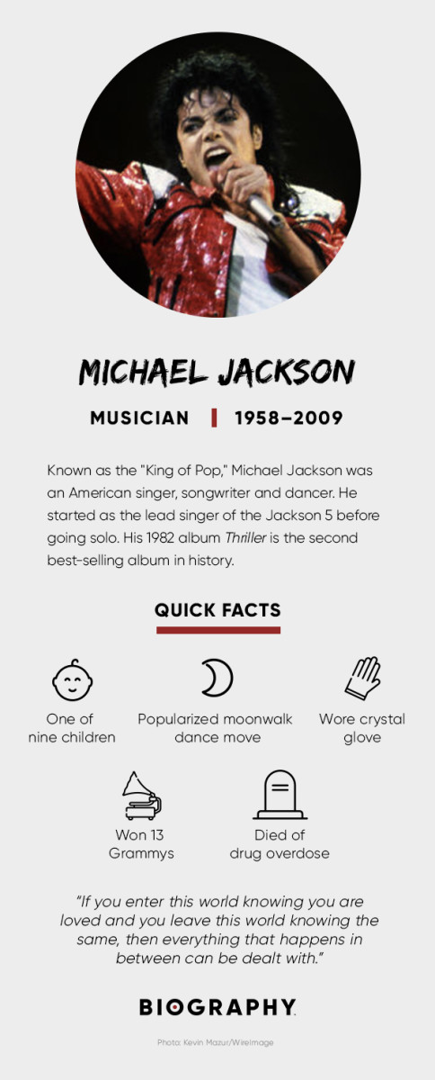Their first album, Diana Ross Presents the Jackson 5, hit the charts in December 1969, with its single, "I Want You Back," reaching No. 1 on the Billboard Hot 100 chart shortly afterward. More chart-topping singles quickly followed, such as "ABC," "The Love You Save" and "I'll Be There."

For several years, Jackson and the Jackson 5 maintained a busy tour and recording schedule, under the supervision of Gordy and his Motown staff. The group became so popular that they even had their own self-titled cartoon show, which ran from 1971 to 1972.

The overwhelmingly positive response to Jackson's 1979 solo album Off the Wall helped the Jacksons as a group. Triumph (1980) sold more than 1 million copies, and the brothers went on an extensive tour to support the recording. At the same time, Jackson continued exploring more ways to branch out on his own.

In 1983, Jackson embarked on his final tour with his brothers to support the album Victory. The one major hit from the recording was Jackson's duet with [Mick Jagger](https://www.biography.com/people/mick-jagger-9351966), "State of Shock."

## **Neverland Ranch**

In the 1980s, Jackson created a Southern California ranch called Neverland, a fantasy retreat for a shy and quiet performer who never was truly comfortable with media attention and rarely gave interviews.

At the 2,700-acre property, Jackson kept exotic pets, such as a chimpanzee named Bubbles. He also installed amusement park-type rides and sometimes opened up the ranch for children's events. The home features six bedrooms, a pool house, three guest homes and a four-acre lake.

The mansion was put on the market for $100 in 2015, then later re-listed for $31 million in early 2019. In December 2020, the property was [sold](https://www.wsj.com/articles/once-asking-100-million-michael-jacksons-neverland-ranch-sells-to-billionaire-ron-burkle-for-22-million-11608817380" \t "https://www.biography.com/musician/_blank) to billionaire Ron Burkle for $22 million.

## **Plastic Surgery 整容**

Jackson was badly injured while filming a commercial for PepsiCo in 1984, suffering burns to his face and scalp. At the top of his game creatively and commercially, Jackson had signed a $5 million endorsement代言deal with the soda giant the previous year. Jackson had surgery to repair his injuries and is believed to have begun experimenting with plastic surgery around this time. His face, especially his nose, would become dramatically altered in the coming years.

Around the late 1980s, rumors began spreading that Jackson was lightening the color of his skin to appear more white and sleeping in a special chamber to increase his lifespan. In 1993, Jackson agreed to a rare television interview with [Oprah Winfrey](https://www.biography.com/people/oprah-winfrey-9534419) to clear rumors. He explained that the change in his skin tone was the result of a skin condition known as vitiligo白癜风, and he opened up about the abuse he suffered from his father.

## **Child Molestation Allegations 虐待儿童质控**

Allegations of child molestation against Jackson first emerged in 1993, when a 13-year-old boy claimed that the music star had fondled him. Jackson was known to have sleepovers with boys at his Neverland Ranch, but this was the first public charge of wrongdoing. The police searched the ranch, but they found no evidence to support the claim. The following year, Jackson settled the case out of court with the boy's family. Other allegations emerged, but Jackson maintained his innocence.

In the 2003 television documentary, Living with Michael Jackson, British journalist Martin Bashir spent several months with the singer, even getting him to discuss his relationships with children. Jackson admitted that he continued to have children sleep over at his ranch, even after the 1993 allegations, and that sometimes he slept with the children in his bed. "Why can't you share your bed? That's the most loving thing to do, to share your bed with someone," Jackson told Bashir.

In 2003, Jackson was arrested on charges related to incidents with a 13-year-old boy. Facing 10 counts in all, he was charged with lewd conduct with a minor, attempted lewd conduct, administering alcohol to facilitate molestation, and conspiracy to commit child abduction, false imprisonment and extortion.

The resulting 2005 trial was a media circus, with fans, detractors and camera crews surrounding the courthouse. More than 130 people testified, including Culkin. The actor told the court that he had been friends with Jackson as a young teen, and never had any problems while staying over at the Neverland Ranch.

Jackson's accuser also appeared via videotape and described how he had been given wine and molested. However, the jury found problems with his testimony, as well as that of his mother. Jackson was found not guilty of all charges on June 14, 2005.

## **Career Decline**

By the turn of the century, Jackson was increasingly becoming known for his ec**centri**cities, which included wearing a surgical mask in public. In 2002, Jackson made headlines when he seemed confused and disoriented on stage at the MTV Video Music Awards. In 2002, he received enormous criticism for dangling his baby son, Blanket, over a balcony while greeting fans in Berlin, Germany. In a later interview, Jackson explained that "We were waiting for thousands of fans down below, and they were chanting they wanted to see my child, so I was kind enough to let them see. I was doing something out of innocence."

In the aftermath of his 2005 trial for child molestation, Jackson's reputation was effectively destroyed and his finances were in shambles. He soon found refuge in his friendship with Bahrain's Prince Salman Bin Hamad Bin Isa Al-Khalifa, who helped the pop star pay his legal and utility bills, and invited him to his country as a personal guest.

In Bahrain, the prince took care of the singer's expenses and built a recording studio for him. In return, Jackson allegedly promised to collaborate on a new album for Al-Khalifa's record label, write an autobiography and create a stage play. The completed work never materialized, however, and Jackson soon faced a $7 million lawsuit from his friend for reneging on his promises.

In even greater financial straits, Jackson defaulted on the $24.5 million loan owed on his Neverland Ranch in 2008. Unable to part with cherished keepsakes, including the crystal gloves he used in performances, Jackson sued to block the auction of some of his personal items from the home the following year.

Around this same time, the largely reclusive Jackson announced that he would be performing a series of concerts as his "final curtain call." Despite all of the allegations and stories of odd behavior, Jackson remained a figure of great interest, as demonstrated by the strong response to his concert plans.

Set to appear at the O2 Arena in London, England, beginning July 8, 2009, Jackson saw all of the tickets to his "This Is It" tour sell out in only four hours. Sadly, Jackson would never get to experience the anticipated success of his comeback tour, as he died in June of that same year.

## **Death**

Jackson [died](https://www.biography.com/news/michael-jackson-final-days) on June 25, 2009, at the age of 50 after suffering a cardiac arrest in his Los Angeles home. CPR attempts failed and he was rushed to the hospital, where he died later that morning. In February 2010, an official coroner's report revealed Jackson's cause of death was acute propofol intoxication, or a lethal overdose on a prescription drug cocktail including the sedatives midazolam, diazepam and lidocaine.

Aided by his personal physician, [Dr. Conrad Murray](https://www.biography.com/people/conrad-murray-481814), Jackson had been taking sedative drugs to help him sleep at night. Murray told police that he believed Jackson had developed a particular addiction to propofol, which Jackson referred to as his "milk." Murray reportedly administered propofol by IV in the evenings, in 50-milligram dosages, and was attempting to wean the pop star off the drug around the time of his death.

A police investigation revealed that Murray was not licensed to prescribe most controlled drugs in the state of California. The steps he had taken to save Jackson also came under scrutiny, as evidence showed that the standard of care for administering propofol had not been met, and the recommended equipment for patient monitoring, precision dosing and resuscitation had not been present.

As a result, Jackson's death was ruled a homicide. Murray was convicted of involuntary manslaughter on November 7, 2011, earning a maximum prison sentence of four years.

## **Funeral and Memorial**

On July 7, 2009, a televised memorial was held for fans of the "King of Pop" at the Staples Center in downtown Los Angeles. While 17,500 free tickets were issued to fans via lottery, an estimated one billion viewers watched the memorial on TV or online.

Jackson's death resulted in an outpouring of public grief and sympathy. Memorials were erected around the world, including one at the arena where he was set to perform and another at his childhood home in Gary, Indiana.

The Jackson family held a private funeral on September 3, 2009, at the Forest Lawn Memorial Park in Glendale, California, for immediate family members and 200 guests. Celebrity mourners included Jackson's ex-wife Presley and actress [Elizabeth Taylor](https://www.biography.com/people/elizabeth-taylor-37991).

Documentary

This is it

Charity work - research

Fame - famous 名气

Reputation 名声 positive negative

Internet violence - public opinion 舆论压力

Controversy controversial figure 争议性人物

Contro verse 段落 words

Mental pressure 心理压力 mental health

Private matters - privacy - deserve public matter

Social influences